Contents

1. CO2 emissions 2

2. CO2 prices 3

3. Oil demand 4

4. Gas demand 5

5. Coal demand 6

6. Biofuel demand 7

7. Wind capacity 8

8. Solar capacity 9

9. EV deployment 10

10. Primary energy consumption 11

11. Technology cost scenarios 12

### CO2 emissions

1. CO2 emissions

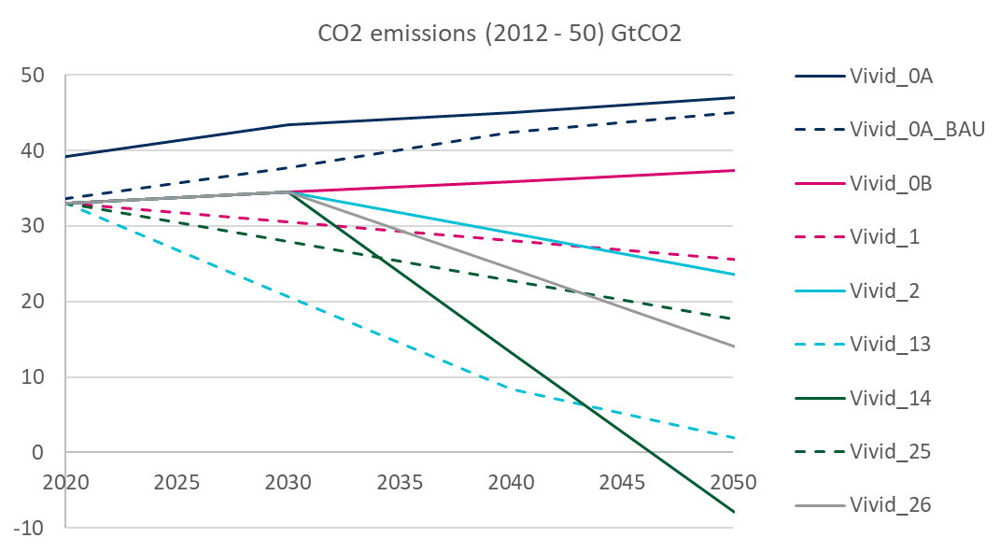



Source: 190129 TIAM Scenario Analysis

#### Issues:

* No issues identified.

### CO2 prices

1. CO2 prices



Source: 190129 TIAM Scenario Analysis

#### Issues:

* No issues identified.

### Oil demand

1. Oil demand based on table ‘AA_PrimaryEnergyProd’

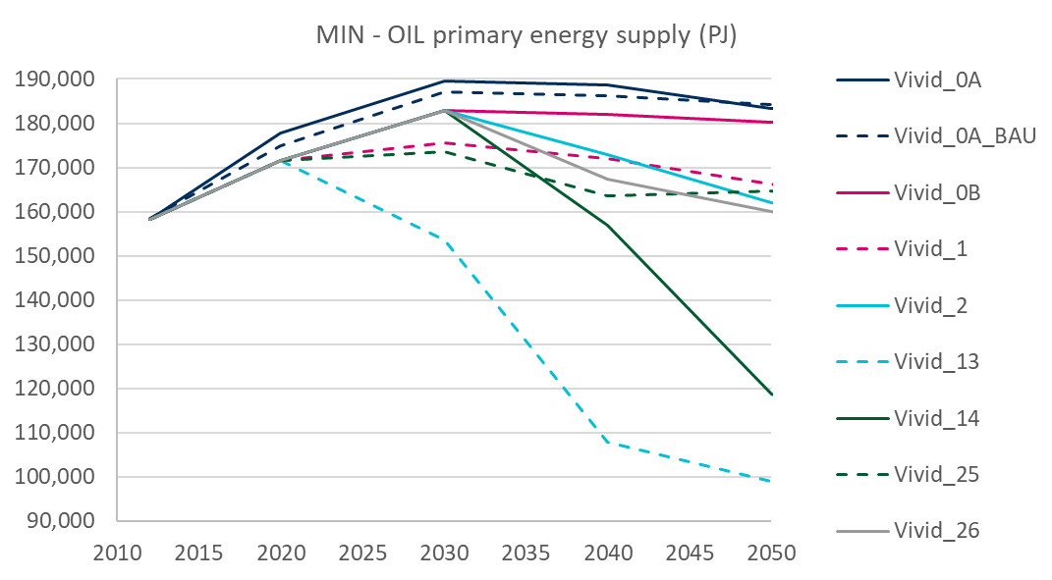



Source: 190129 TIAM Scenario Analysis

#### Issues:

* No issues – profiles are improved for last set of runs.

### Coal demand

1. Coal demand

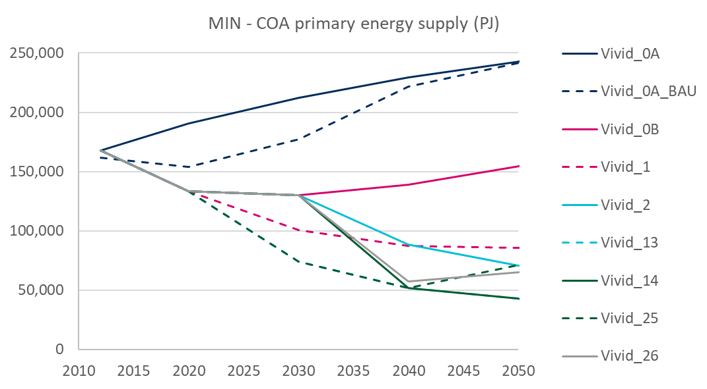



Source: 190129 TIAM Scenario Analysis

#### Issues:

* Q. Vivid_25 and Vivid_26 have higher coal demand from 2040 to 2050. Could you please explain what is driving this?  
  Note that this has been a feature of the scenario runs since the BHP set as shown in the figure above, so may not be driven by just the in-year emissions constraints we have implemented in the new set of scenario runs
* Q. Scenarios in general continue to have high coal demand in 2040 and 2050. By comparison IEA ETP B2DS gets to 42,000 PJ in 2050, and their assumptions around renewable deployment are very conservative. What is driving this?

### Gas demand

1. Gas demand

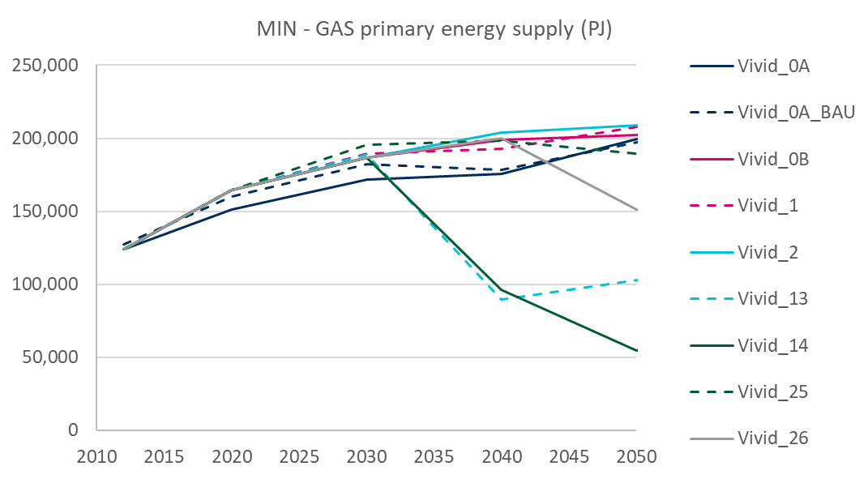



Source: 190129 TIAM Scenario Analysis

#### Issues:

* No issues identified

### Biofuel demand

1. Biofuel demand

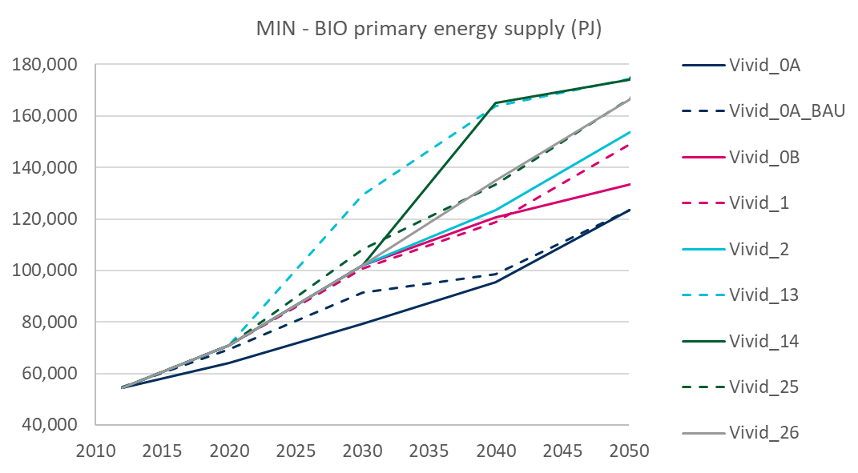



Source: 190129 TIAM Scenario Analysis

#### Issues:

* No issues identified.

### Wind capacity

1. Wind capacity

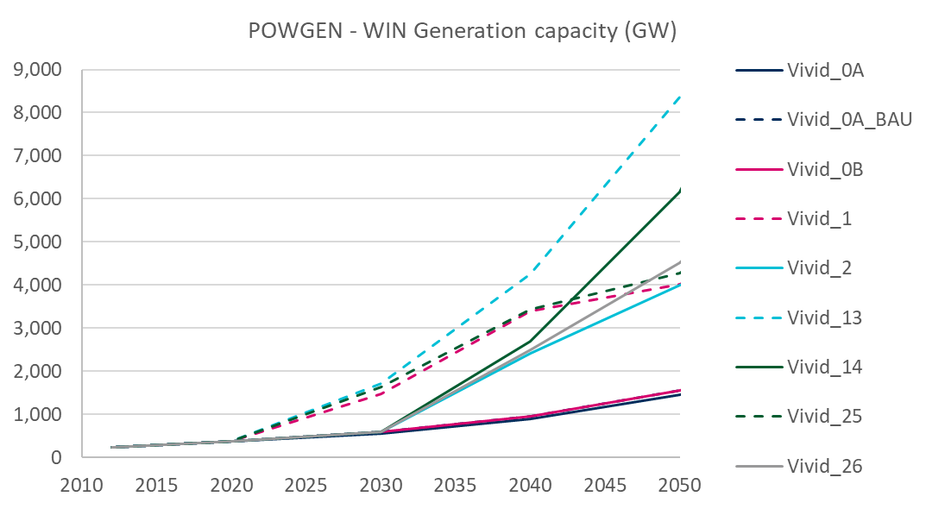



Source: 190129 TIAM Scenario Analysis

#### Issues:

* No issues

### Solar capacity

1. Solar capacity

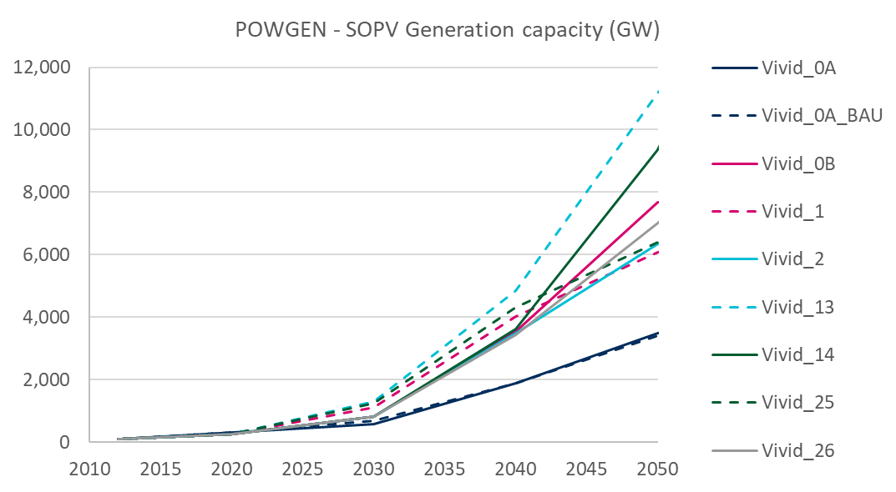



Source: 190129 TIAM Scenario Analysis

#### Issues:

* **Very high solar deployment under Vivid_0B:**
  + Q. There is higher solar PV generation capacity deployment in Vivid_0B compared to Vivid_1 and Vivid_25 in 2050
  + Q. Looking at the delayed scenarios (Vivid_2 and Vivid_26), Vivid_0B is higher on solar PV deployment in 2040

### EV deployment

1. EV deployment

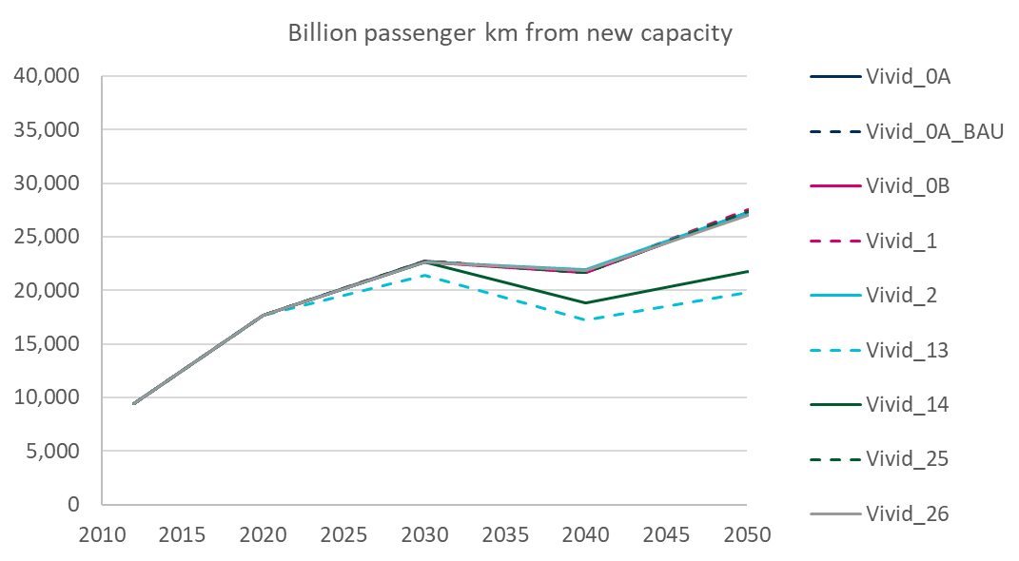



Source: 190129 TIAM Scenario Analysis

#### Issues:

* **Q. Are we interpreting the above table correctly as billion passenger km met by new EV capacity in each snapshot year?**
  + The above suggests that there is no uptake or even a slight decrease in EV capacity deployment in the climate policy scenarios compared to the baselines
  + However, both total power generation levels and oil demand estimates suggest the opposite – that is, power generation levels have risen in the cheap EVs scenarios compared to the baseline (‘vanilla technology cost’ scenario), and oil demand has fallen relative to the same scenario **[see Figure in section 11]**

### Primary energy consumption

1. Primary energy consumption

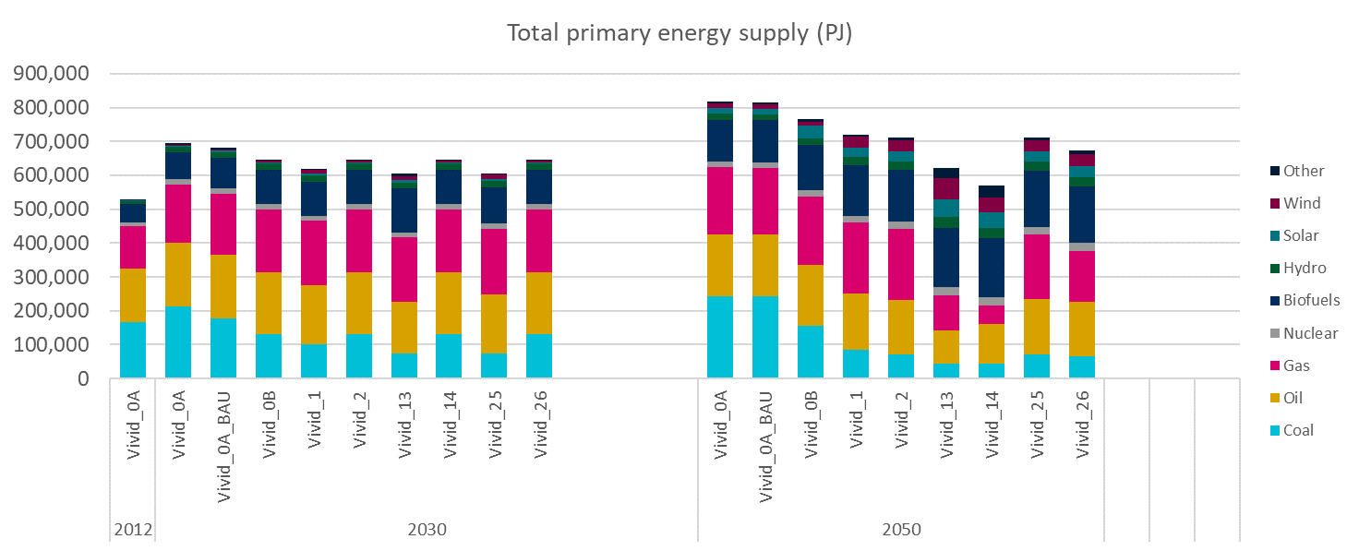

Source: 190129 TIAM Scenario Analysis

#### Issues:

* No issues identified

### Technology cost scenarios

1. Cheap EV-2DS (Vivid_7) vs Vanilla-2DS (Vivid_1)

**NEW EV CAPACITY**

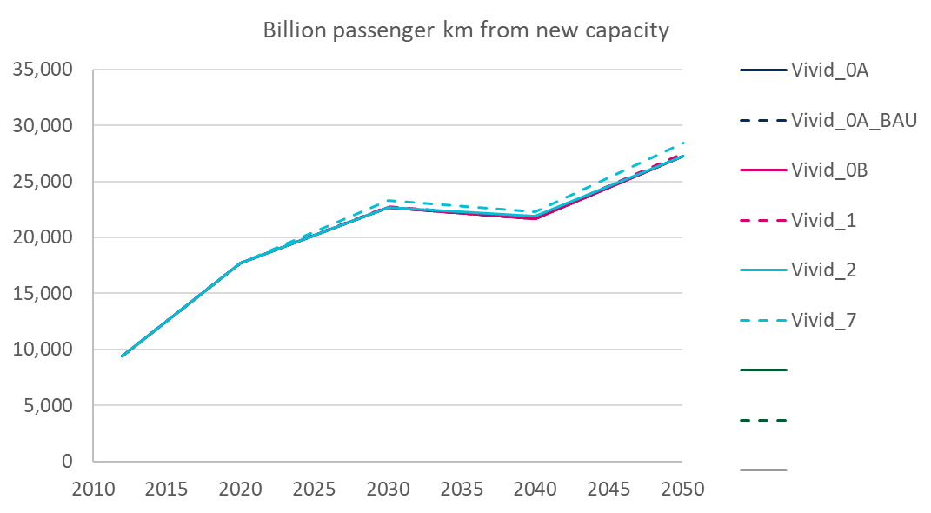



**OIL DEMAND**

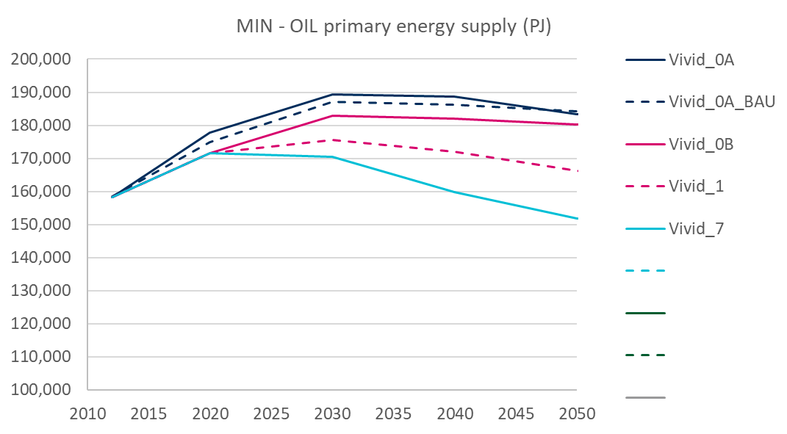



Source: 190129 TIAM Scenario Analysis

#### Issues

* As per charts above, there is no increase in EV km driven in cheap EVs scenarios, however, there is a considerable reduction in oil demand (Vivid_7)  
  **Is it possible that we have the wrong indicator for EV deployment / there is an error in the processing of the output data there?**

1. Cheap renewables-2DS (Vivid_3) vs Vanilla-2DS (Vivid_1)

**SOLAR CAPACITY**

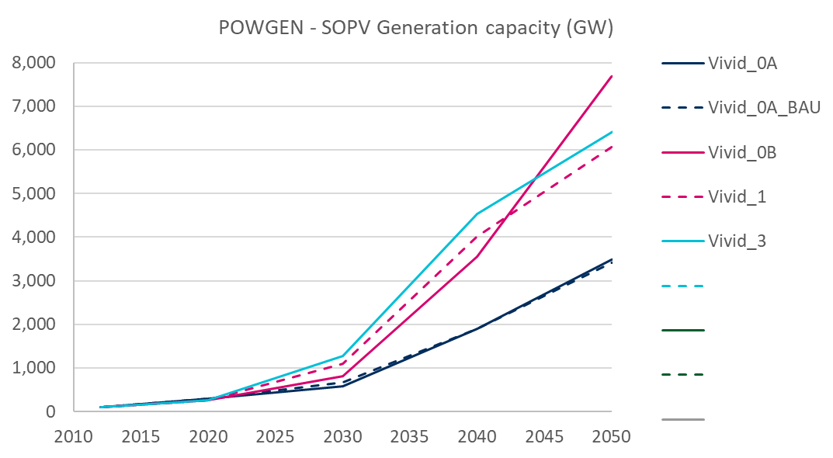



**WIND CAPACITY**

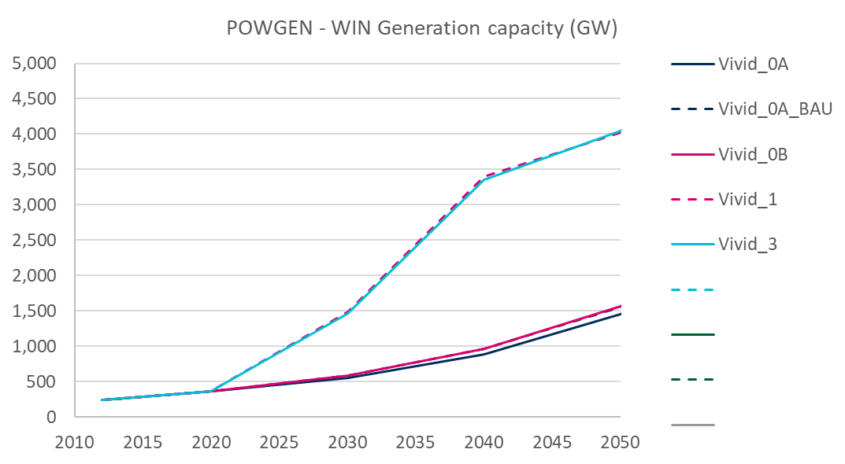



Source: 190129 TIAM Scenario Analysis

#### Issues

* Cheap renewables leads to lower wind deployment in 2040 and 2050 compared to ‘vanilla’ technology cost scenarios.  
  **Is there an issue here? In general, can we make both wind and solar cheaper in the cheap renewables scenario**
* Solar is slightly higher in Vivid_3 (cheap renewables) compared to Vivid_1. **Can we make solar even cheaper as discussed in the email chain?**

1. Cheap CCS-2DS (Vivid_5) vs Vanilla-2DS (Vivid_1)

**GAS DEMAND**

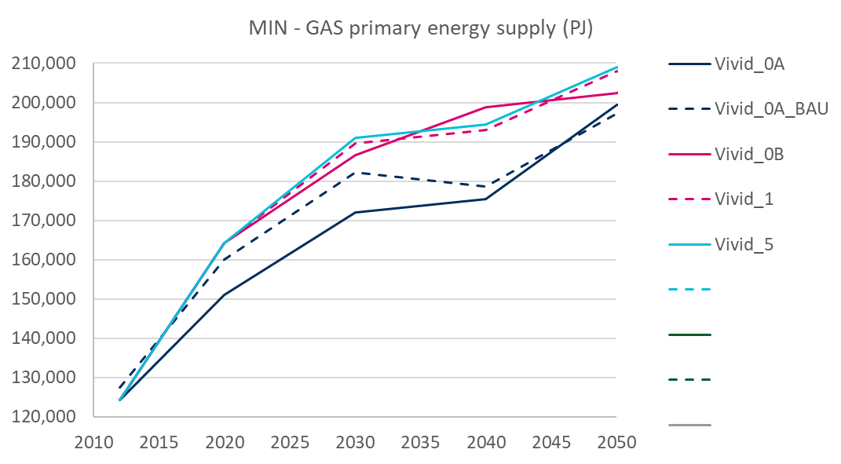



**BIO CCS CAPACITY**

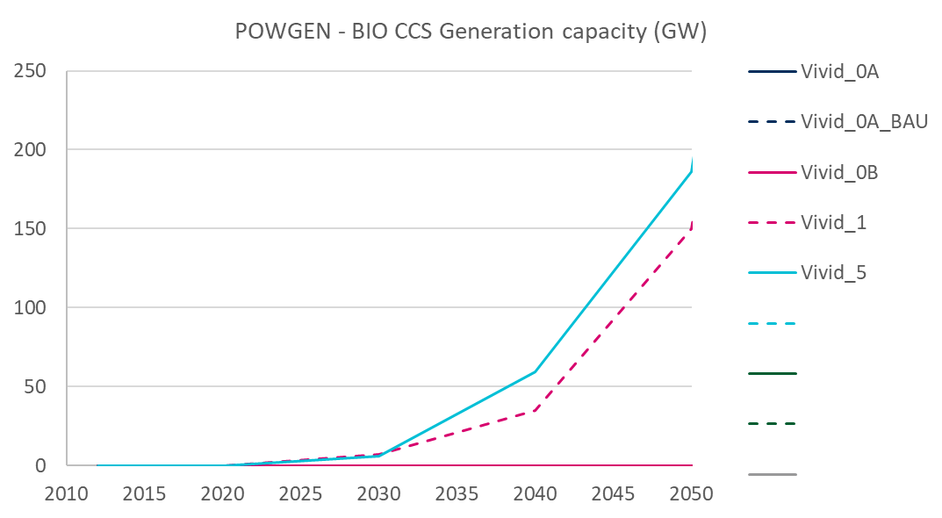



**SOLAR CAPACITY**

**WIND CAPACITY**

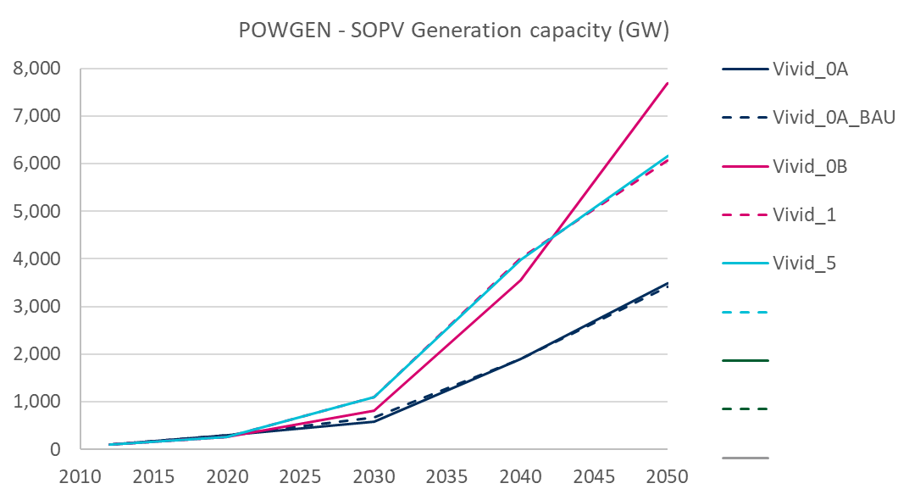



Source: 190129 TIAM Scenario Analysis

#### Issues

* As with cheap renewables scenario (Vivid_3), cheap CCS (Vivid_5) seems to have very limited effect which is likely due to the things you mention in your email.
* Key outputs to look at are Gas Demand and Bio CCS Capacity (Charts presented above).
* On Gas Demand: As seen from the first chart cheap CCS seems to reduce gas demand in 2050. This suggests that there is no additional gas with CCS in our cheap CCS scenario which is a bit in contrast with what I would expect.
* On Bio CCS Capacity: There is a bit more uptake in cheap CCS but levels are still negligible.
* **Can we be even more aggressive on the technology cost assumptions in the cheap CCS scenario as discussed in the email chain?**
* **Note that in the old BHP scenario runs, we had considerably more gas use in the cheap CCS scenario than we did in the vanilla technology cost scenario**